Facebook and Fake News

Consider each of the below proposals, and fill in each of the below TODOs.

# Proposals

## Proposal 1

Facebook relies on an algorithm as well as individual users’ reports to identify content that is potentially "fake news." Once the content has been identified, it is sent to third party fact-checkers for verification. If the content is verified as fake news, it is publicly flagged with a warning that the content is disputed by fact-checkers.

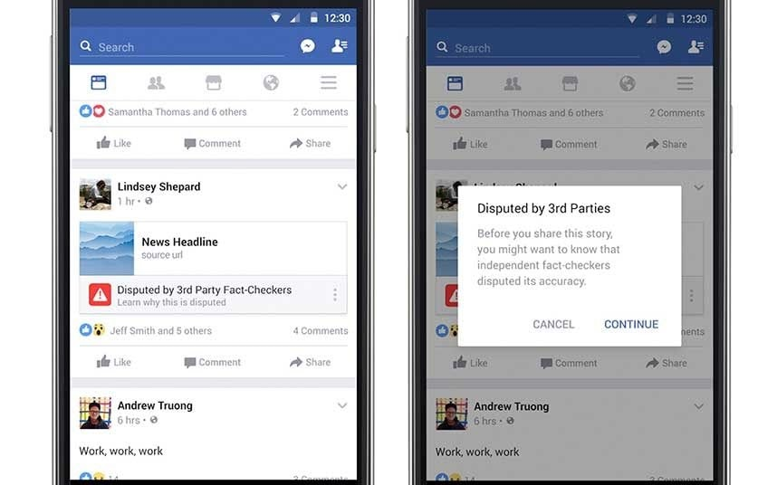

## Proposal 2

However, a designer at Facebook believes that there needs to be a different approach to content regulation. Their proposal is that content deemed problematic by third-party fact-checkers should be prevented from being shared on the platform altogether.

# 

# Questions

1. Which form of content regulation, Proposal 1 or Proposal 2, do you feel is better? Why?
   1. I am personally in favor of the first one rather than the second one. Social media in root is still a world for communication, information exchange, which embeds the rights of freedom of speech. As described in above, first one is intending to develop a system complementing the existing one, double checking validity of the information while does not impair people’s expressing rights. While on the other hand, the second one does not even offer an opportunity for voicing out. In a way, platform users might be dis-encouraged even telling truths.
2. Which form of content regulation, Proposal 1 or Proposal 2, do you think best preserves or promotes the [five rights and opportunities necessary for a democratic public sphere](https://cs50.harvard.edu/college/2020/fall/labs/10/lecture/#five-rights-and-opportunities-for-a-democratic-public-sphere)?
   1. Which proposal best preserves or promotes Rights? Why?
      1. First. Because I think the foremost and essential right of social media is freedom of speech. There can be other rights, such as getting the valid information as much as possible, the security concerns, but all these are secondary compare to the speech necessity.
   2. Which proposal best preserves or promotes Opportunity for Expression? Why?
      1. First. Even though the two are all for eliminating fake news, the first proposal is utilizing the post-check method while the second is more like a precaution – stopping people from expressing.
   3. Which proposal best preserves or promotes Access? Why?
      1. I would argue the first functions slightly better in Access. In my opinion, access is the combination of “availability” and “validity”. From the availability perspective, as long as more information is available, they can be ascertained by the public. Public also has their own ability judging which should be believed in. From the validity perspective, filtering out fake news ahead helps in improving validity, but there is also potential risk in wrongdoing.
   4. Which proposal best preserves or promotes Diversity? Why?
      1. First. The fundamental of Diversity, in my opinion, is enough samples. In this case, the samples can be perceived as messages or posts on the social media.
   5. Which proposal best preserves or promotes Communicative Power? Why?
      1. Second. Communicative Power is shown by exchanging valid information and improving efficiency. When thinking about the above two proposals, first will be less likely providing reliable news compare to the second one. The efficiency, on the other hand, can only be better presented with higher proportion of truths. Information quality saves people’s communicative time in filtering and testing the information.